New Order Forms
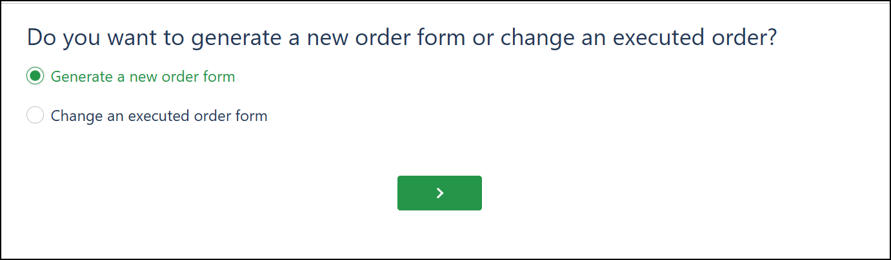
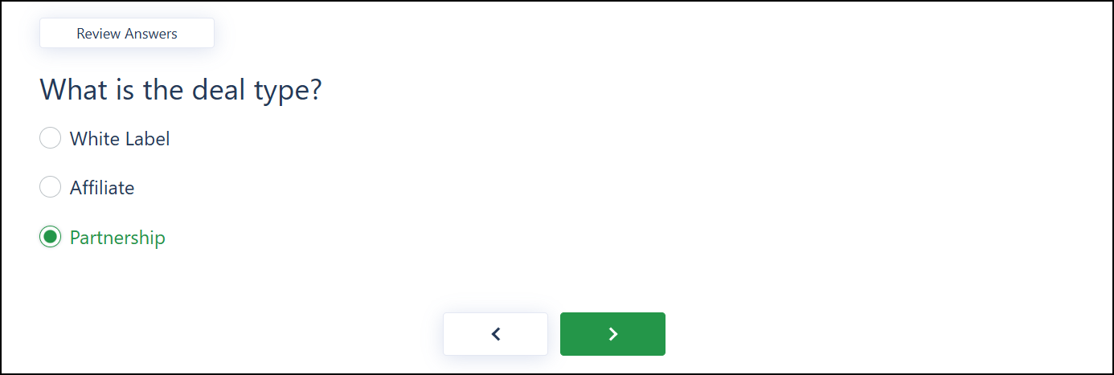
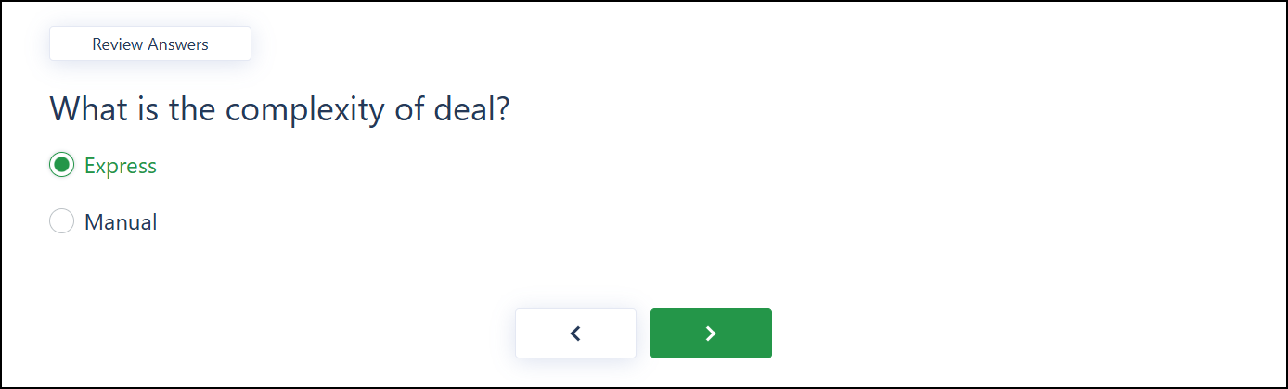
See page 2

Allow the following question to be edited in the Express Workflow.
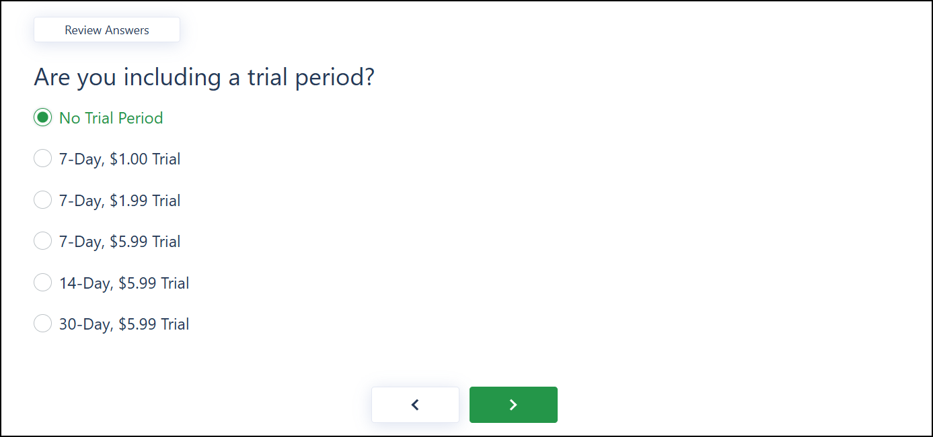
Remove the default Retail Price and allow Reps to tailor the retail price for Build Plan and Protect Plan.
